Question 1: Gender Identity – 1. How would you describe your gender?
Female |  | Male |  | Prefer not to answer

Question 2: Gender Identity – 2. Have you ever identified as a transgender person or trans person?
Yes |  | No |  | Prefer not to answer

Question 3: Marital Status. What is your legal marital status?
Single |  | Married/Civil Partnership |  | Widowed |  | Living with partner
Divorced/Separated |  | Prefer not to answer

Question 4: Age. What is your date of birth?
Day: |  | Month: |  | Year: |  | Prefer not to answer

Question 5: Caring Responsibilities. Do you have caring responsibilities?
Yes (children under 18) |  | Yes, other |  | No |  | Prefer not to answer

Question 6: Religion or Belief. What is your religion or belief?
Buddhist |  | Church of Scotland |  | Hindu |  | Humanist
Jewish |  | Muslim |  | None |  | Other Christian
Sikh |  | Pagan |  | Roman Catholic |  | Prefer not to answer
Other, please specify:

Question 7: National Identity. What is your national identity?
Scottish |  | English |  | Welsh |  | Northern Irish
British |  | Prefer not to answer
Other, please specify:

Question 8: Ethnic Group. What is your ethnic group? Choose one from section A to F?
A. White
Scottish |  | Other British |  | Irish |  | Gypsy Traveller
Eastern European  (eg polish) |  | Other
B. Mixed or Multiple Ethnic Group
Any mixed or multiple ethnic groups
C. Asian, Asian Scottish or Asian British
Pakistani, Pakistani Scottish or Pakistani British |  |  |  | Indian, Indian Scottish, Indian British
Bangladeshi, Bangladeshi Scottish or Bangladeshi British |  |  |  | Chinese, Chinese Scottish or Chinese British
Other
D. African
African, African Scottish or African British |  |  |  | Other
E. Caribbean or Black
Caribbean, Caribbean Scottish or Caribbean British |  |  |  | Black, Black Scottish or Black British
Other
F. Other Ethnic Group
Arab, Arab Scottish, or Arab British |  |  |  | Other
Prefer not to answer
Other, please specify:

Question 9: Disability. Do you consider that you have a disability?
Yes |  | No |  | Prefer not to answer

Question 10: Disability (impairment). If yes to the above question, please state the type of impairment which applies to you.
If none of the categories apply, please specify the type of impairment in ‘other’.
Learning Disability, (such as Down’s syndrome or dyslexia) or cognitive impairment (such as autism or head-injury) |  | Longstanding illness or health condition such as cancer, HIV, diabetes, chronic heart disease or epilepsy |  | Mental Health Condition, such as depression or schizophrenia
Physical Impairment, such as difficulty using your arms or mobility issues which means using a wheelchair or crutches |  | Sensory Impairment, such as being blind/having a serious visual impairment or being deaf/having a serious hearing impairment |  | Prefer not to answer
Other, please specify:

Question 11: Sexual Orientation. What is your sexual orientation?
Bisexual |  | Gay |  | Heterosexual/Straight |  | Lesbian |  | Prefer not to answer

Question 12: Council Employee. For existing Council employees only, are you applying for a promoted post?
Yes |  | No |  | Prefer not to answer

This information will be treated in the strictest confidence

ABERDEEN CITY COUNCIL

DIVERSITY AND EQUALITIES MONITORING FORM

Candidate ID |  | Advert Reference | ABC

PLEASE COMPLETE AND RETURN WITH THE APPLICATION FORM AND CRIMINAL CONVICTION MONITORING FORM.

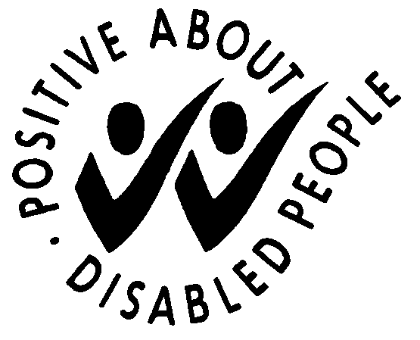

THIS FORM IS AVAILABLE IN LARGE PRINT IF REQUIRED. PLEASE CONTACT (01224) 814924 TO OBTAIN A COPY

